Devops Day2

Create a project in the organization

Go to repos->add readme file->Initialize

Copy the https link and generate git credentials

Cloning a azure repository in git bash

Step1: while asking authentication click use another accountand click the same azure account

Step2: Generate git credentials and click use another account and use the password there.

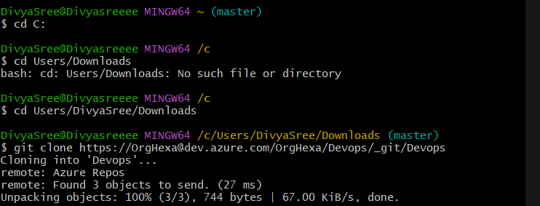

To create simple text file, give the command touch “filename” then push to git

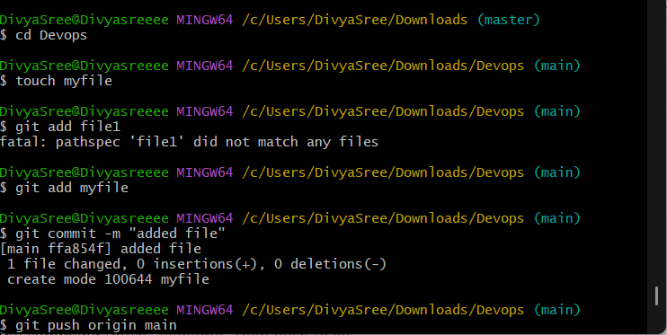

To add multiple files at a time

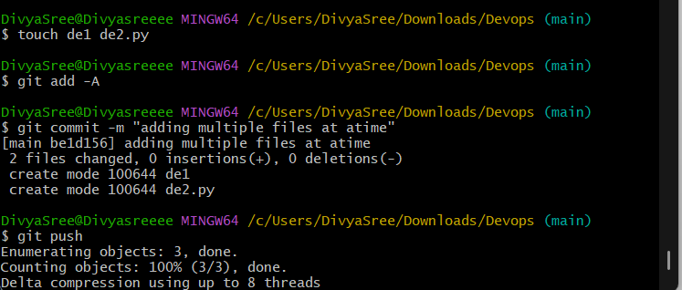

Ruunning a job by using starter pipeline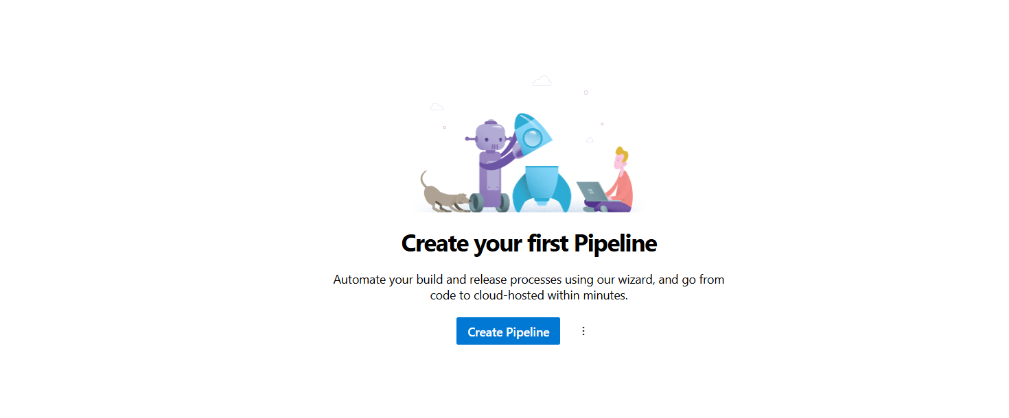

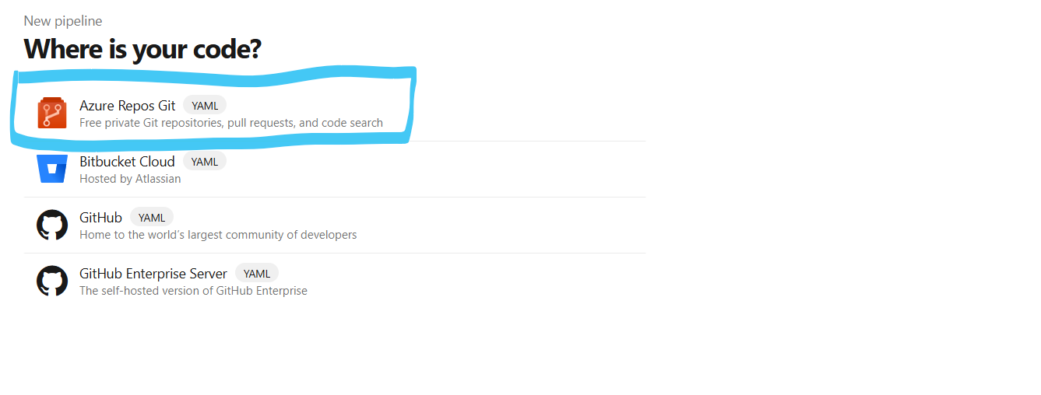

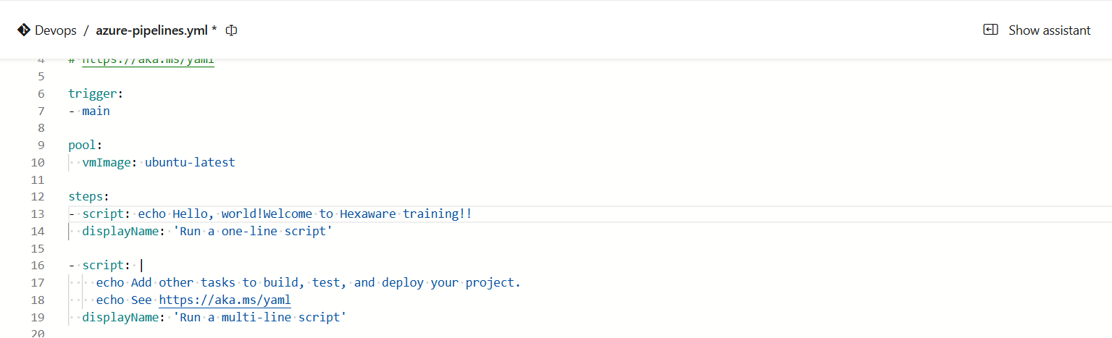

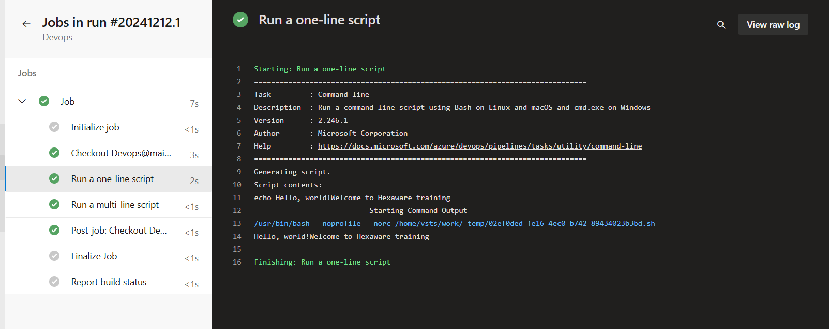

In organization settings got to personal access tokens and create it,copy it.

In azure databricks, create worksace with premium subscription and go to settings->Linked accounts

Give azuser mail id in username and provide personal access token there

